**Experimental Graph**

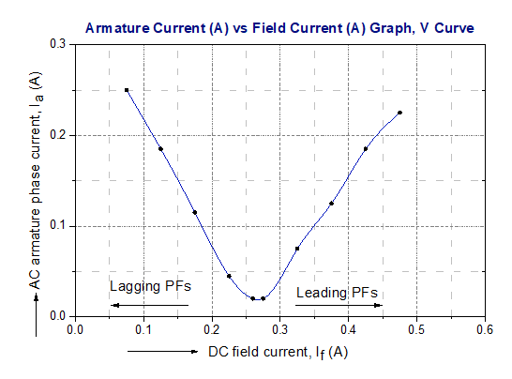

**Figure 01:** Relation between armature current and field current.

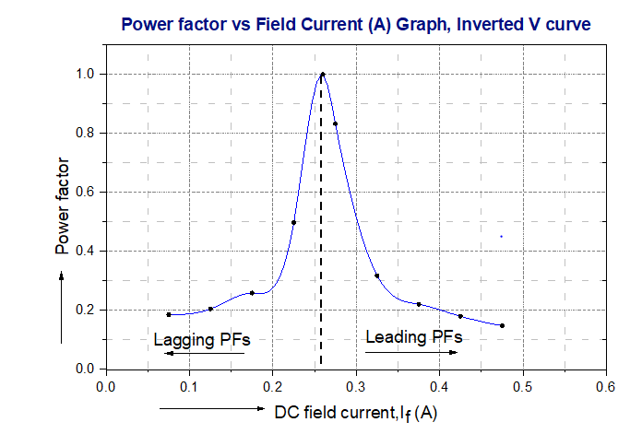

**Figure 02:** Relation between power factor and field current.